A short history of Oak House, 7 Northgate Street, Ipswich, Suffolk
Formerly “The Royal Oak” Inn, “Pykenham House” and colloquially referred to as
“The Old House”

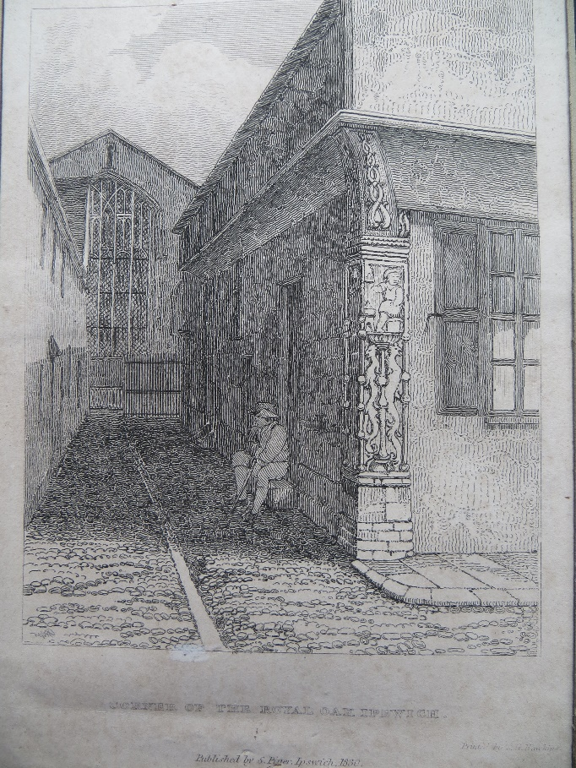

Paul Bridges Stevens

March 2018
Copyright Jackamans Solicitors Ipswich

Foreword
I joined Jackamans in 2003 at their Ipswich office, and became acquainted with Oak House and its quirky charm. Over the years, many clients have asked me about the history of the building and it has only usually been possible to show them the magnificent red leather-bound album of black and white photos and refer to it having once been an Inn before concentrating on the legal advice to hand.
I had decided some years ago that I would write a short history that clients who are interested could take away and read at their leisure, and indeed I did carry out some researchs but never felt I had quite enough of the story to go to print. Now I am approaching retirement from the Partnership at the end of March 2018 and this has concentrated my mind to complete the task. I still do not have the fullest of histories to relate but this is the first edition and as more research is carried out, and more documentation revealed those may be added to subsequent editions. At least this is a start.
I want to thank my colleague, Consultant Ruth Jenkins for her invaluable help with the research, particularly with census records, British Newspaper Archives, and ancestry.co.uk. I would also like to thank Dr Hannah Cutler of the Suffolk County Council Archaeological Service for searching the County Historic Environment Record, and other material.

Paul Stevens

The Royal Oak Inn
The first record of the building I have managed to establish is in 1689, where it is referred to as “Tudor house on corner post, mentioned in 1689 under the name of the Royal Oak Inn. Corner of Oak Lane and Northgate Street “. It had been in existence since the 15th or 16th century, but I have not been able to obtain any more information of its earlier life. The licence for the Inn had been transferred from an Inn of the same name in Tavern Street in 1689.
The Inn had been built near to the North Gate of Ipswich Town and had no doubt been frequented by traders and travellers for some refreshment over the centuries as they arrived or departed from or into the surrounding country roads.
I have obtained a copy of a drawing of the North Gate dated 1729 thanks to A. J. Rawling Optometrist of 14 Northgate Street. This image is reproduced below:

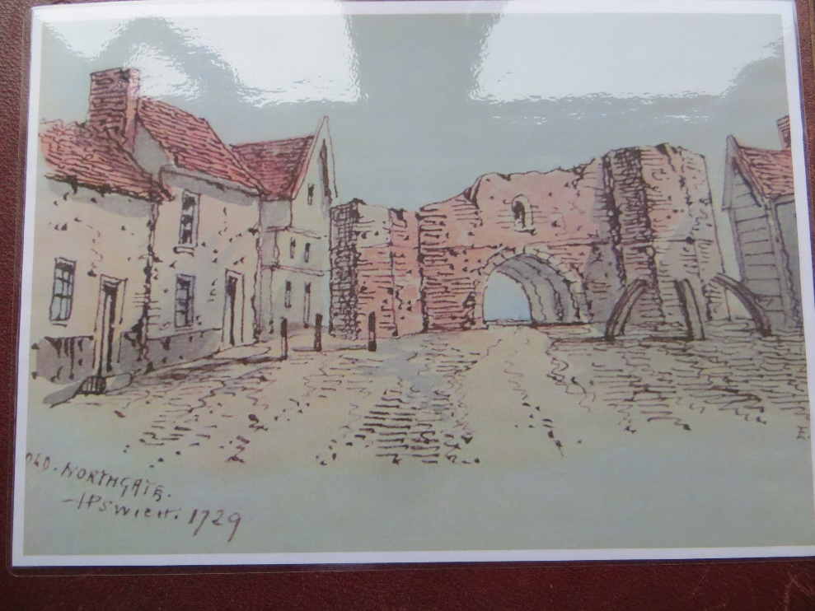
The building immediately to the left of the tower of the Gate is the Halberd Inn, today known as McGintys. Subsequent to this image the old North Gate was demolished, and its bricks and stones were used to build other structures.
The next image I have found of the Royal Oak is an 1830 etching showing the famous corner post and a view of Oak Lane looking towards the Eastern End of St Margaret’s Church.
It was by George Frost and reproduced in “The History of the Town and Borough of Ipswich” by G.R Clarke published in 1830.

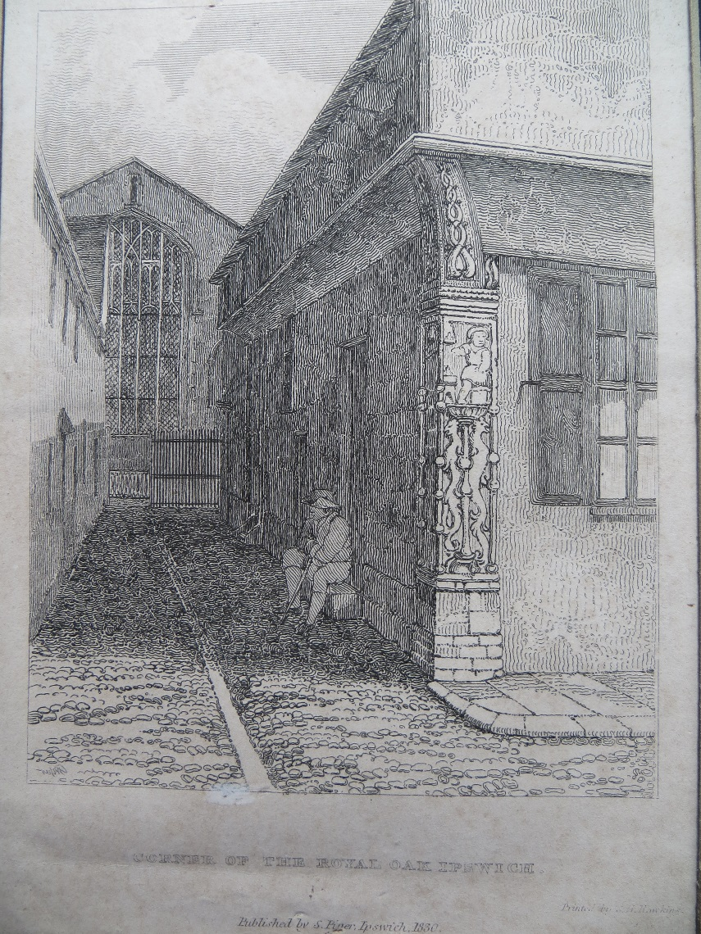

The character in the picture looks at peace with the world, no doubt sitting on the doorstep of the side entrance to the Inn before taking some refreshment within. The stick he cradles suggests he may be disabled in some way, perhaps a wounded sailor. The corner post is drawn in some detail and is highly ornamental, representing on one face a blacksmith striking an anvil, on the other a female head with beret. I am certain that this is the same corner post as Oak House is attached to today. The remainder of the post is decorated with a combination of candelabra and grotesques which it has been suggested could date from the 1530s. The female head may be intended as a welcome for visitors, and the blacksmith as providing care for the visitors’ horses. Another description of this post appeared in “The Builder “Illustrated Magazine for 1847 which stated:”The upper purlin on one side represents a blacksmith at his forge, and on the other, a female head – perhaps one is Vulcan , the other Venus . Beneath the figures is an enriched scroll – ornament with heads of griffins & co, in the style of the Renaissance “
Another image of the Royal Oak follows. It is undated and is a very impressive close-up detail of the corner post. It differs from the previous one in that the name of the Inn now appears in a panel above the window and the open shutter is being used to advertise the sale of London Porter. As there is no date on the picture one can only guess that it dates from the middle part of the nineteenth century when Porter beer was at its most popular. This picture was printed in the Ipswich Star in January 1973 in some interesting articles about the building being raised to Grade One listed status around 1972. I will refer to these articles later on in some more detail.

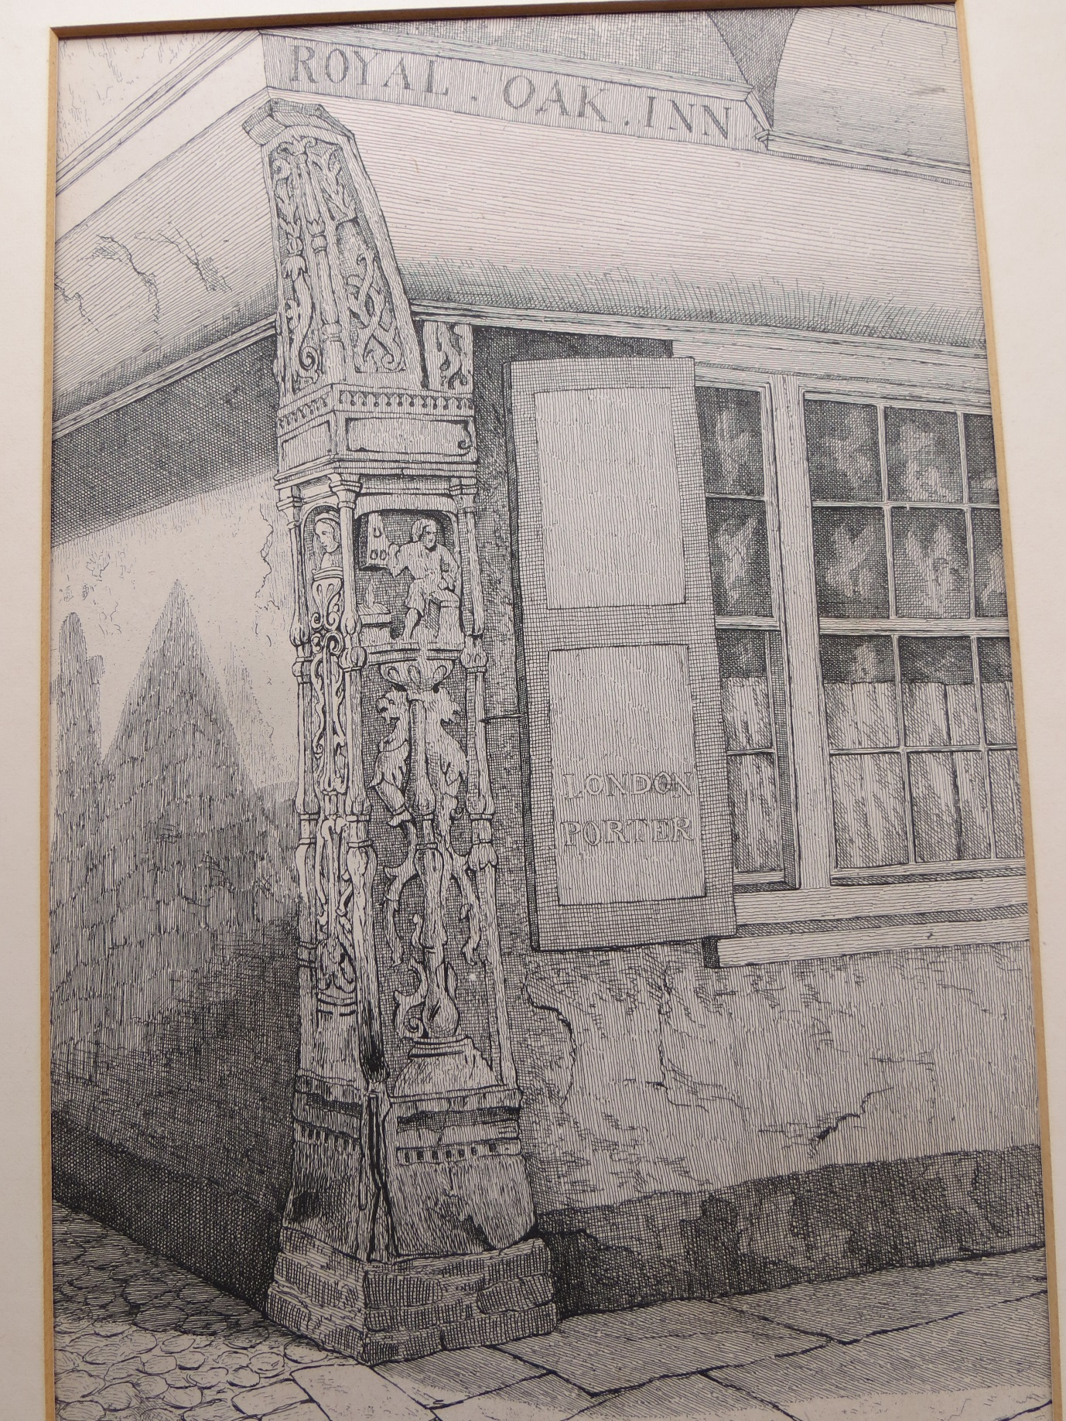
The picture hangs in the reception area of Oak House today, as does the previous one .

I will refer to one more picture of the Royal Oak Inn before moving on to other aspects of its history. In July 2006 the existence of a painting was brought to the attention of the Partners of Jackamans (the firm name then was Jackaman Smith and Mulley) by fine art dealer John Allen of Norwich. He thought the painting might be of interest because it depicted the Royal Oak Inn, Northgate Street and was by a celebrated artist. Here it is:

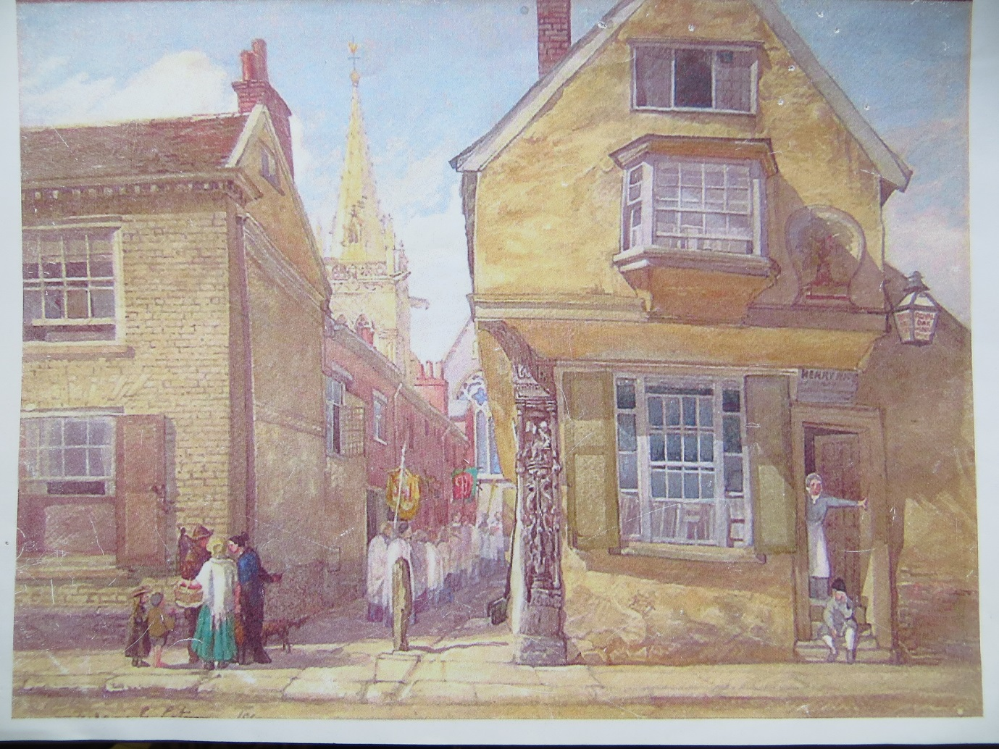
The painting is dated 1869 and signed F.G.Cotman . It is a watercolour. Frederick George Cotman was born in Ipswich in 1850, where his father was a silk merchant. He had an elder sister, Margueritta, and two older brothers , Thomas and Henry who will play a part in the story later on. Frederick painted this wonderful picture when he was only nineteen and he would go on to become a successful artist in his later life. He studied at the Ipswich Art School and later at the Royal Academy London where he was awarded a gold medal for his work. His uncle was John Sell Cotman (1782-1842) the famed marine and landscape painter and leading member of the Norwich school of artists. Apart from depicting the Royal Oak in some detail, it shows the church “Quire” proceeding down Oak Lane probably during a Rogation ceremony, as well as some local people in conversation. At the time of the painting, as far as we know, neither Frederick nor his family had any connection with the Royal Oak, apart from no doubt imbibing the odd refreshment at the Inn, particularly after turning out an impressive masterpiece!
In his later career Frederick Cotman painted in oil and watercolour a full range of subjects, including portraits, which he could sell for high prices. Unfortunately, the sale of Frederick’s painting to Jackamans did not take place.
Thanks to Ruth Jenkins’ research, I have been able to gain a little more detail of the life and times of the Royal Oak and its publicans over the centuries .
One extraordinary entry in the Ipswich Journal of 1st December 1781 stated:
”Notice is hereby given to all Gentlemen and others, who are much annoyed with those vermin, called rats, that they have now an opportunity of being released of such a nuisance, by applying to the famous Mr John Stibard, rat destroyer to be heard of at the Royal Oak in Ipswich, during the winter season, who has given such proofs of his abilities to the gentlemen of Yarmouth and its environs ..”
A salutary lesson next appears in the Ipswich Journal of 23 April 1791 as to the vicissitudes of the trade of publican where it appeared:
“Debtors and Creditors; Whereas James Deeks at the Royal Oak Ipswich, having assigned over his effects to Joshua Head, beer brewer, and Henry Gallant, brandy merchant, for the benefit of his creditors, all persons who have any claim or demand on the aforesaid James Deeks are desired to meet at the Royal Oak .. To be let, and entered upon immediately The Royal Oak Public House“.
The next entry in the Ipswich Journal for 14th May 1791 is more hopeful:
“Royal Oak – Brook Street Ipswich; Joseph Cooper begs leave to inform his friends that he has taken the above house; and having laid in a fresh stock of the best Spirituous Liquors and Wines humbly solicits the favours of the late customers, and the public in general, who may depend upon his utmost endeavours to accommodate them “.
I will refer to one other newspaper report as regards the Royal Oak, which appeared in the Ipswich Journal on 2nd December 1843:
“Public Houses: The Ipswich Police have strict orders to make examples of those publicans who violate the tenor of their licences. On Monday last, John Robinson, landlord of the “Royal Oak” Public House, Northgate Street, was convicted before the magistrates at the Town Hall of permitting his house to be the resort of thieves and prostitutes, to the great annoyance of the whole neighbourhood. The defendant having had repeated cautions on the subject was fined £3 and costs, and allowed a week for payment “. £3.00 in 1843 is worth about £300.00 today.
A list of publicans of the Royal Oak appear below:
1830 Thomas Savage (Whites Gazette)
1839 John Robinson (Pigot)
1844 John Robinson (Whites) – He seems to have weathered his bad press at the magistrates’ court in 1843!
1855 Robert George Boby (Whites)
1861 William Flory – Member of the Ipswich Lodge of Freemasons, described as a cab proprietor
1869 Henry Price Post Office Directory
1871 Henry Price
1874 Henry Price (Whites)
1879 William Brown (Kellys Directory) .
There was a strong link between the Royal Oak and cab and coaching services. In 1817 for example coaches left daily from the Royal Oak to Hadleigh, Landguard Fort and Stonham.
This section of the history of the building nears an end. The next significant event is in September 1881 when a report in the Ipswich Journal announced that John Chevalier Cobbold (Owner) and James Goodall Gooding (dealer) were applying for the provisional removal of the licence from the Royal Oak, Northgate Street, and intending to apply for a new licence for a house, owned by John Cobbold, to be built abutting Derby Road, towards the East , and the Felixstowe Road to the South. In fact, the new house became in the same year the new “Royal Oak” at 175 Felixstowe Road, and our building appears to have reverted to plain number 7 Northgate Street.

The Cotmans
and Thomas Parkington

The next chapter of the history begins with number 7 being purchased by Thomas William Cotman, Architect, in 1883.
As stated above he was an elder brother of F.G Cotman the artist. He was the third child of Henry Edmund Cotman (1802-1871), silk mercer of Norwich, and had been born in Bermondsey London in 1847. The family moved to Ipswich when the children were young. The 1851 census shows the Cotman family living at 29 Mount Street Ipswich, head of household Henry aged 50, his wife Maria 36, Margueritta 8, Thomas 3, and Frederick newly born. In fact the eldest son Henry, who would have been 7, does not appear in the census as he may have been away at school, but he does appear in the 1861 census living with the family at a new address in Ipswich.
Thomas studied at the Ipswich School of Art and in 1869 he set up as an architect in Cutler Street Ipswich, later moving his business address to St Nicholas Street Ipswich . In the 1871 census he is shown aged 23, living with his parents at 95 London Road Ipswich as the only sibling at that time. Thomas was obviously a talented artist and was a member of the Ipswich Art Club from 1885-1915 and exhibited one of his watercolours, “Boston Stump” while at St Nicholas Street. But Thomas was to be a successful and prolific architect for his working life.
Thomas Cotman’s career portfolio of buildings, designed and built, is no doubt a large one, but unfortunately, I have not been able to establish a comprehensive list. Instead, I can refer to some of them to illustrate the enduring importance and quality of his work:

Felixstowe Railway Station; Harvest House Felixstowe; Lloyds Bank Building Lloyds Avenue Ipswich; Crown and Anchor Hotel (WH Smiths building) Ipswich; Fore Street Baths Ipswich; Former Chelsea Building Society Offices Princes Street Ipswich; 140-2 Nacton Road. He also designed the new Royal Oak premises on the Felixstowe Road Ipswich.
This is quite an impressive list on its own, but I must now return to recall the history of 7 Northgate Street. What did it look like in 1883 when Thomas bought it? I have no sure idea, but I can reproduce some postcards which I think date from around that time:

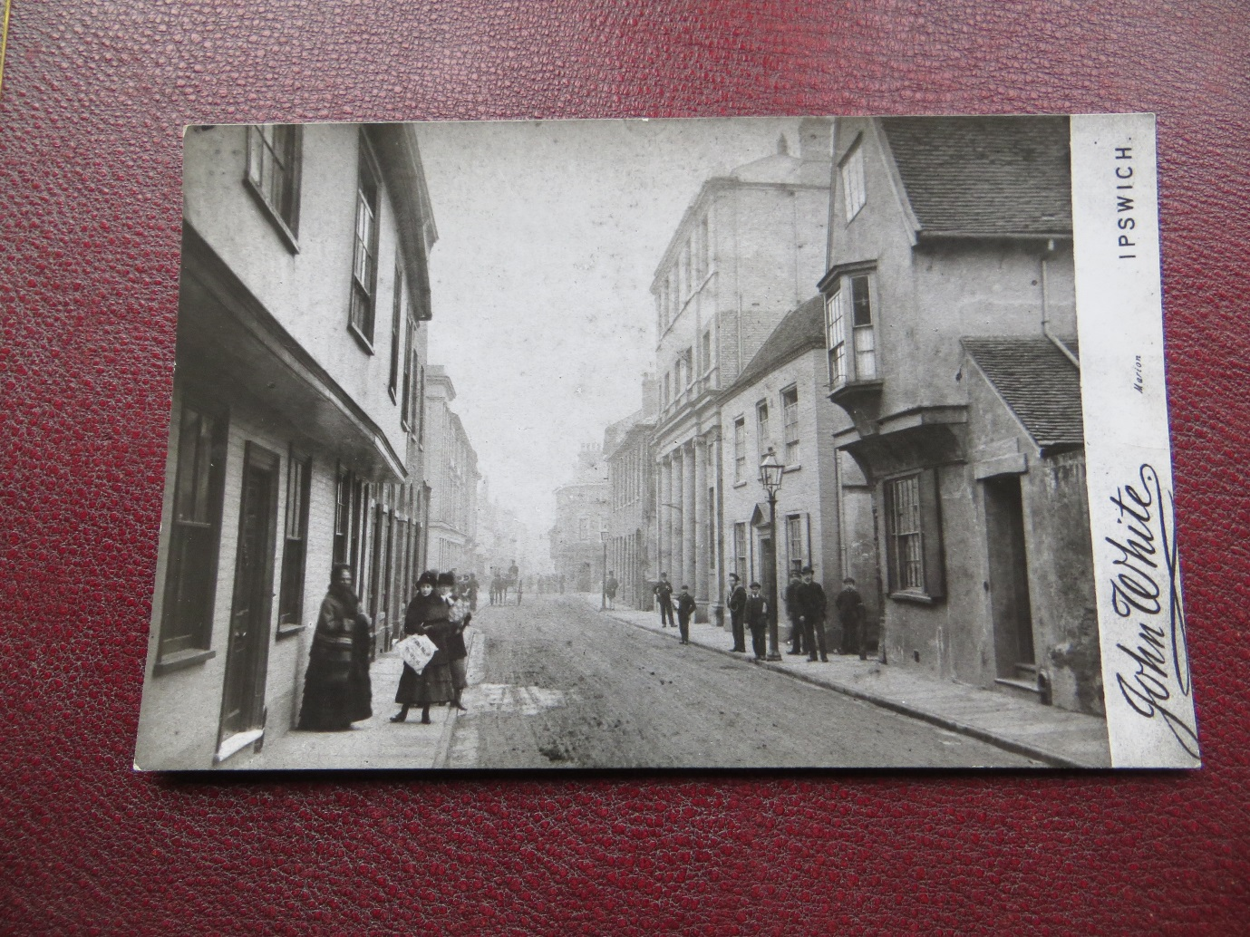
I am no expert on late Victorian dress, but these good folk of Ipswich could well be posing in 1883 with 7 Northgate Street no longer an inn but an architect’s home and office. I could be wrong!

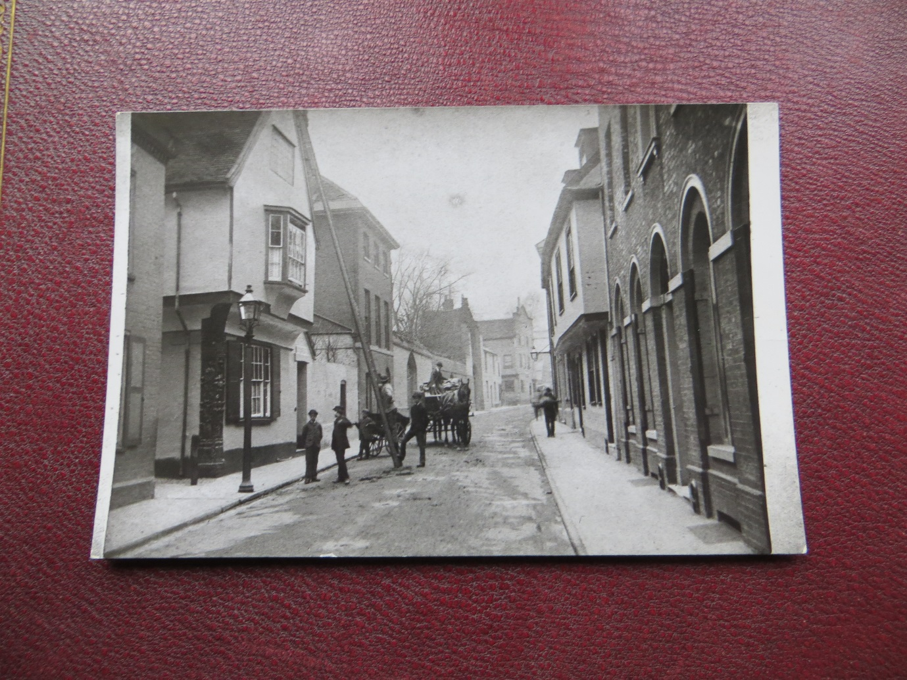
This one may be a little later in time, showing the building from its southern aspect, looking in good condition, and getting what looks like some essential maintenance from the arranged artisans .
The 1891 census shows the occupiers of 7 Northgate Street as follows:
Thomas William Cotman; 43; head; single; architect
Henry Edmund Cotman; 46; brother; single; architect’s assistant
Paul Eade; 21; nephew; single; architect’s assistant
Maria Cotman; 77; mother; widow
Caroline Ramsey; 20; servant; single; domestic servant
Alice Smith; 19; servant; single; housemaid
Mary Rendall; 29; servant; single; trained nurse.
This was a large household, dependant on Thomas Cotman’s continuing success and no doubt significant hard work, supported by his brother and nephew. His mother was probably in declining health as evidenced by the attendance of a nurse. She died in 1895.
But something was very much in the offing as regards the future of 7 Northgate Street. Its shape, size, style and image would all undergo a radical transformation by the time of the 1901 census. It would be a far cry from the images of the Royal Oak which have appeared before in this brief history. The one constant will be the wonderful mediaeval corner post which will anchor the building forever to its past.
I will mention one unsubstantiated theory about the building’s transformation at this time. In John Allen’s 2006 letter to the Partners, he had stated that it had burnt to the ground in 1889 and was rebuilt as offices in 1895, incorporating the carved corner post, the only original building to survive the fire intact. I am afraid I do not think this can be correct for a number of reasons: It was clearly being used as a home and architect’s office in 1891, and without having any forensic training on the subject, the corner post shows no signs of any fire damage whatsoever from what would have been a very severe fire scene, attended by relatively primitive Victorian fire appliances. Finally, I have not come across any other reference to this event having taken place. Obviously, I stand to be corrected, as usual!
Without any specific documentation as to the story of the transformation I will do my best to interpret what happened from what I do know, or think I know! I referred earlier to some articles which appeared in the Evening Star in 1972-3. This correspondence arose from Oak House, as it would become later, being given Grade 1 listed building status as a building of historic or architectural interest in 1972. I managed to locate these articles from research at the Suffolk Record Office. One article dated 1st January 1973 (45 years ago now) is entitled “Is it a fake?”, and goes on to quote one reader who said “The only genuine bit is the corner post – all the rest was rebuilt about 60 years ago using materials from other buildings that had been demolished ……………………. the reconstruction was carried out in the early years of this century by an architect, well known locally as Cotman ……… much of the credit for the restoration is sometimes given to Thomas Parkington“.
This is not much to go on, but it does make sense based on other evidence. There is no doubt that Thomas Cotman as owner of 7 Northgate Street would want to see his and his family’s home improved in the best light. Maybe the old Inn building was just not big enough for the family, and his business. The site was large enough to extend the building significantly to the north, as it had contained the old Inn stable yard, with just a single storey structure on it. Another factor which I believe drove the project was Thomas Cotman’s professional pride in creating a truly exceptional building from the old, preserving faithfully the lines of the old Royal Oak and its corner post, but creating a new and unique face on Northgate Street. It could also not do any harm to his prospects of new projects from his appreciative clients!
I have not come across any direct evidence yet that Thomas Parkington , an Ipswich builder, was responsible for the building work at 7 Northgate Street, but it is known that he and Thomas Cotman worked together on the construction of the magnificent Fore Street Baths which were opened in March 1894. Another interesting feature of this story is that Thomas Robert Pearl Parkington (to give him his full name) who was born on 2nd November 1866, and died on 24th June 1942, was also an artist and a Fellow of the Royal Society of Arts, and in 1926 he purchased the near derelict Flatford Mill and dilapidated Willy Lotts House. Parkington carried out basic repairs and opened the Flatford Mill as an Arts and Leisure Centre. He gifted both properties to the National Trust in his will. No philistine, jerry building profiteer was he. He lived at 7 Northgate Street, after it had been re-named Pykenham House, as his home from the 1930s until his death together with his wife Florence Ellen Parkington. This would have been after Thomas Cotman and his family had sold up and retired to Felixstowe in 1913. I think that Cotman and Parkington made an ideal team to transform the building ambitiously, imaginatively, appropriately, and sympathetically for the benefit of future generations.
Here is an early photograph of T.R.Parkington:

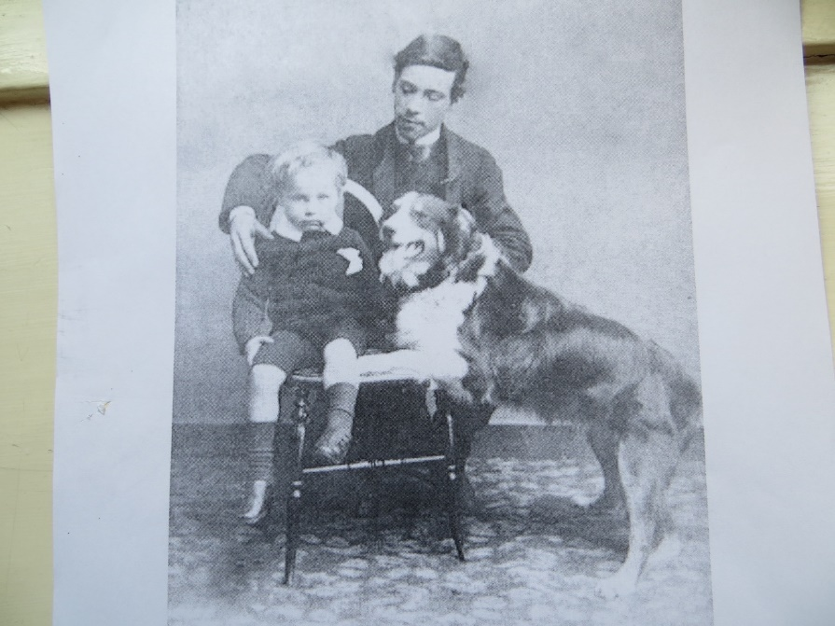
It shows him and his much younger brother John and the border collie “Borzoi” taken in 1885. He was a great animal lover and would go on to become President of the RSPCA, Ipswich Branch.

Thomas Parkington travelled to South Africa in 1888, when he was in his early twenties. Much later in his life in 1933 he wrote up the story of this adventure in a short book called “South Africa – The Country of the Future; Recollections of a Pioneer “. He was clearly much taken with the Country as he said in its closing paragraph “If I had my time over again, South Africa would be the land of my adoption.”
There is no doubt that when completed the new building contained some extraordinary features, such as stained-glass windows, doors, fireplaces, panelling, timbers, and friezes which had come almost certainly from demolished old buildings located in the area. This may sound opportunist by today’s standards but in the closing years of the nineteenth century there was very little - if any - protection given to buildings of historical, architectural or cultural importance and maybe the only way Cotman and Parkington could do anything was to use the few remaining precious artefacts from the lost treasures in their new creation.

And so, the new building was born. I believe that by 1901 it was completed, but as usual I am open to correction. Thomas Cotman commissioned celebrated photographer Thomas Lewis of Stratford Road, Sparkbrook, Birmingham to take the stunning series of black and white photographs of the new building which are contained in the red leather-bound album kept at Oak House today. Here are some of the images:

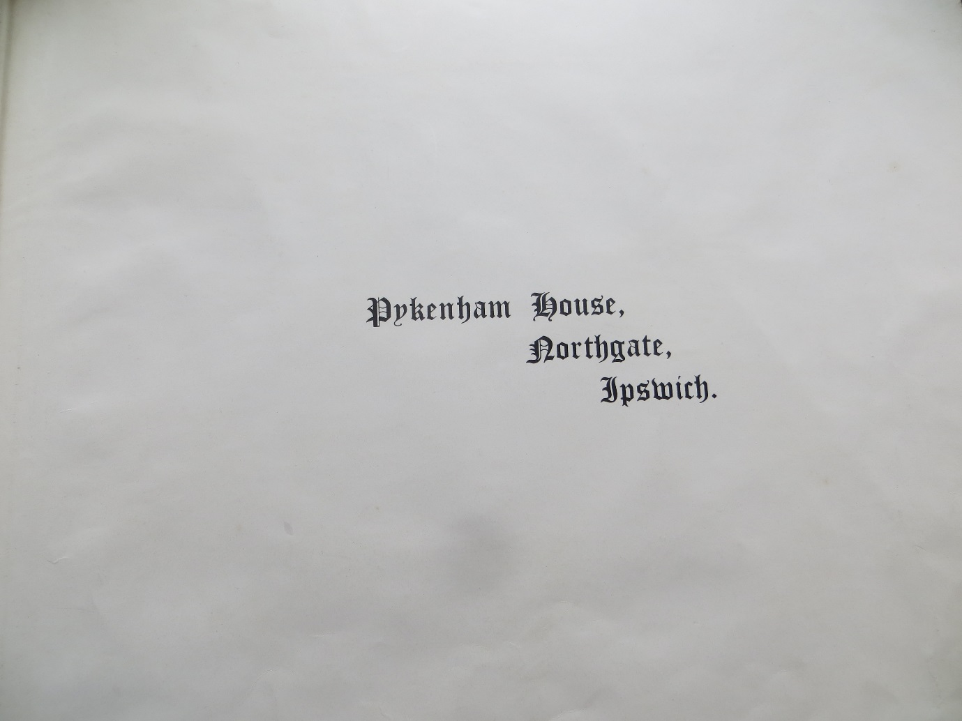

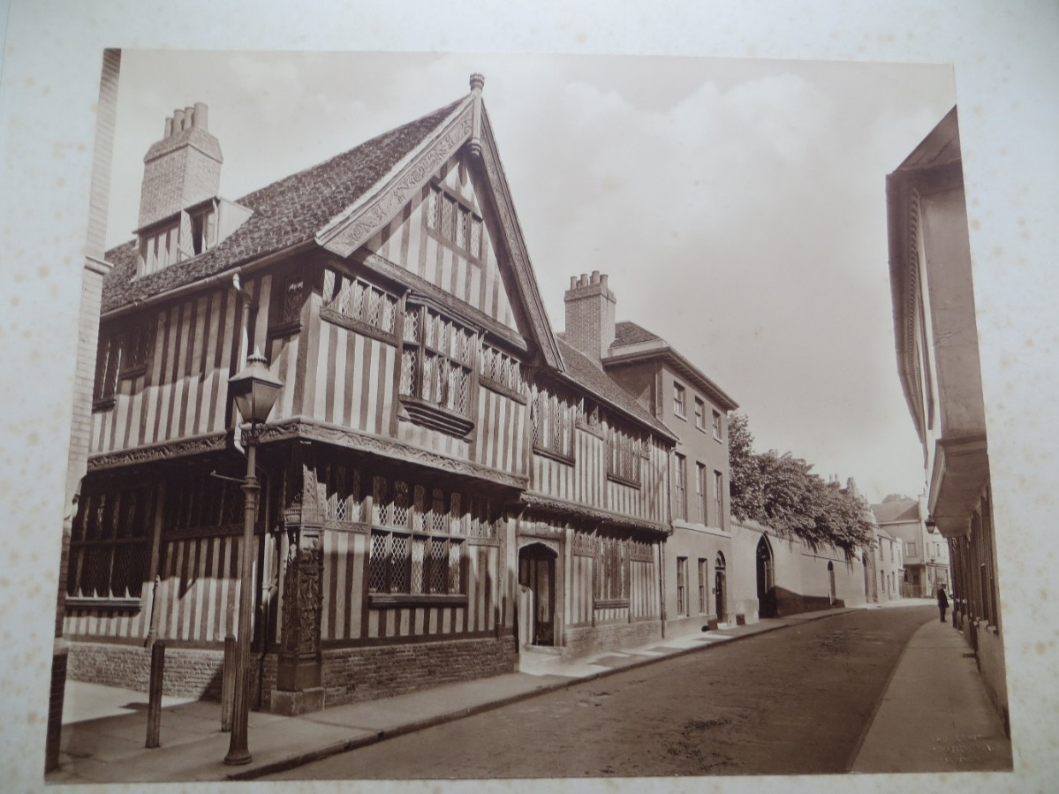

The motto in Latin over the door reads “Ne Tentes aut perfice “, which translates as “Do not attempt it, unless you carry it out thoroughly “. It is not known where the carved wooden coat of arms originated from, but it makes a pretty appropriate motto for an architect, or indeed for a firm of solicitors for that matter!

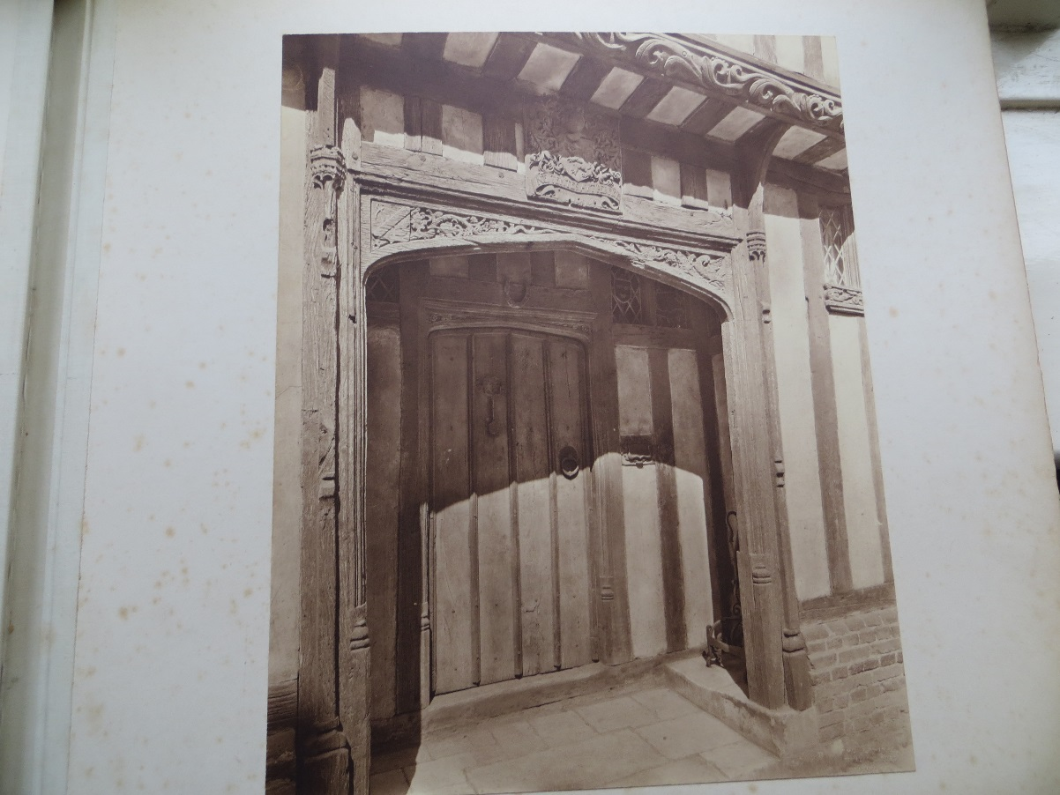

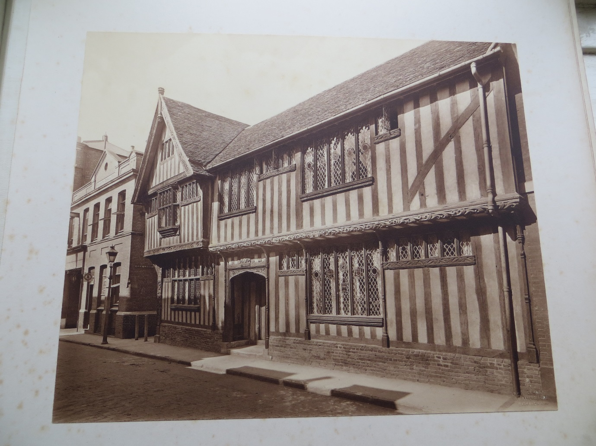
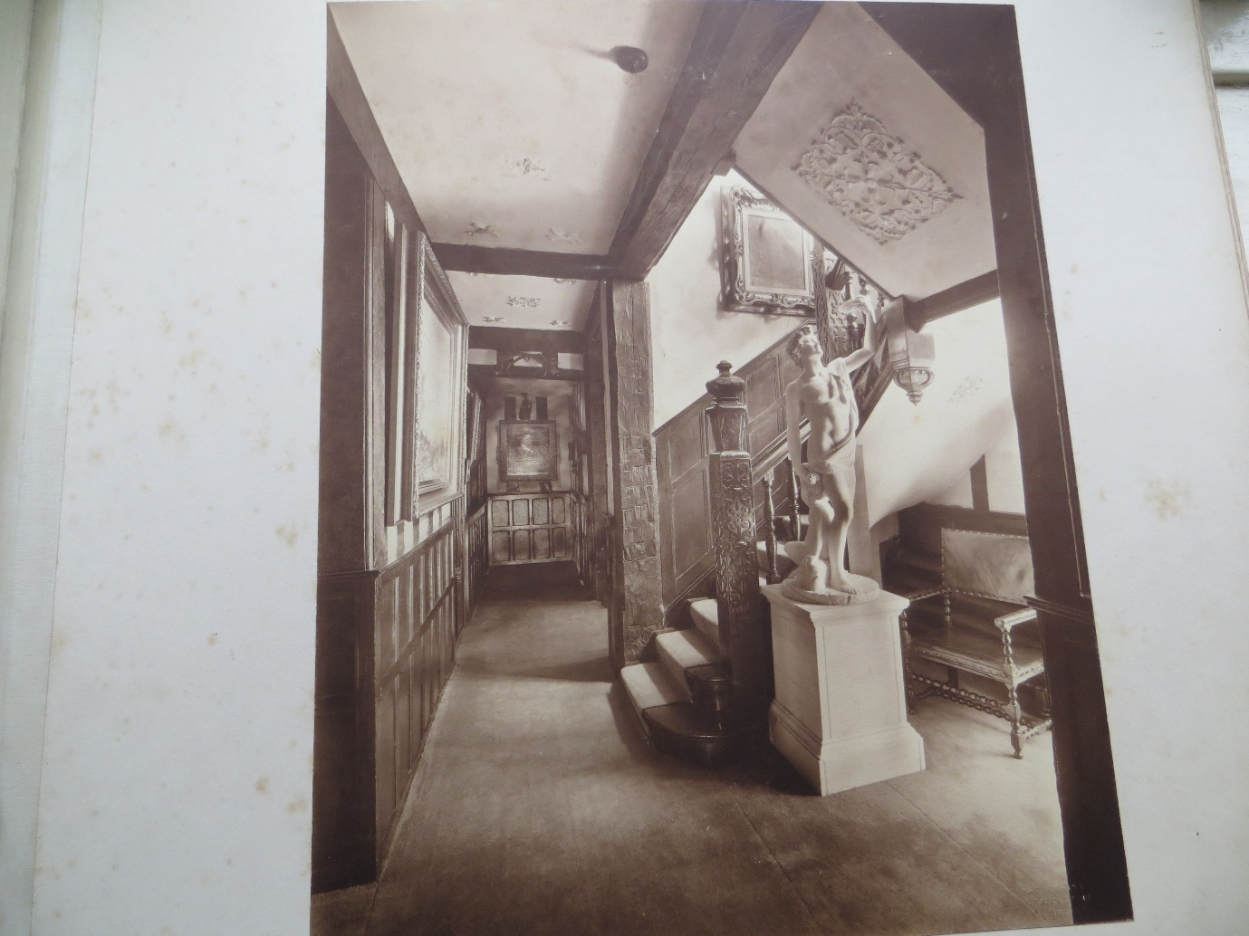
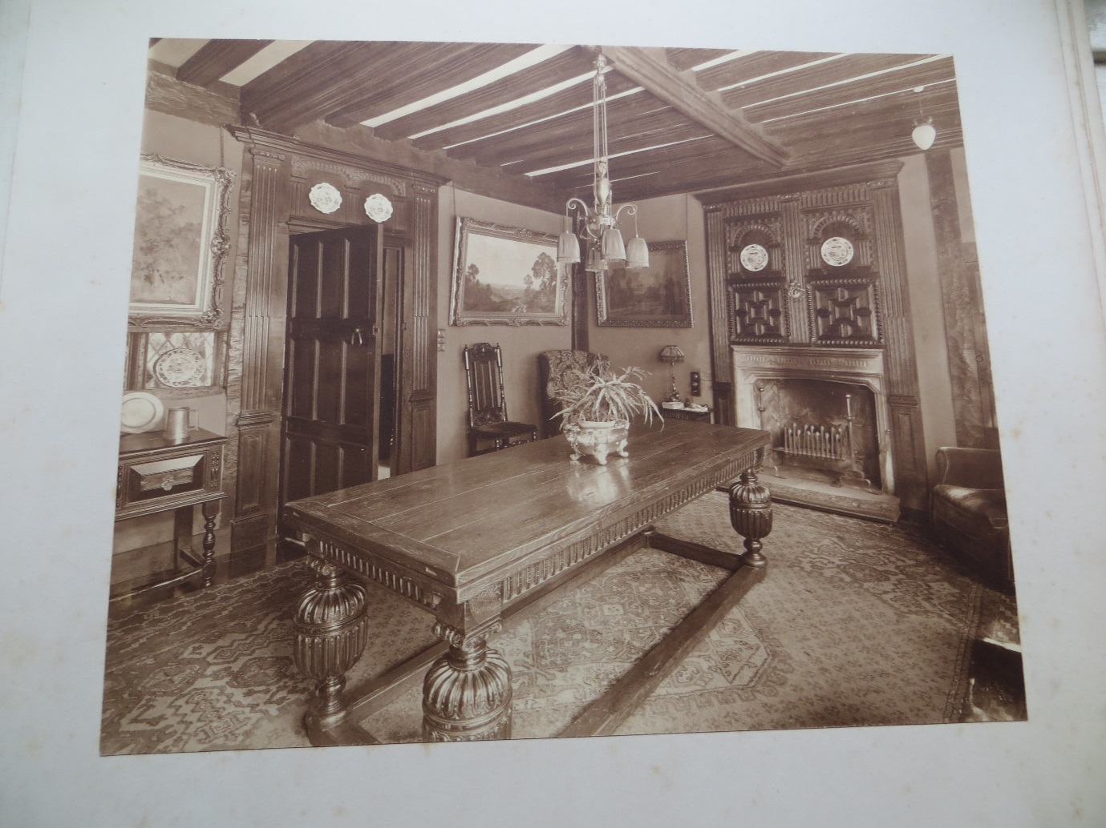
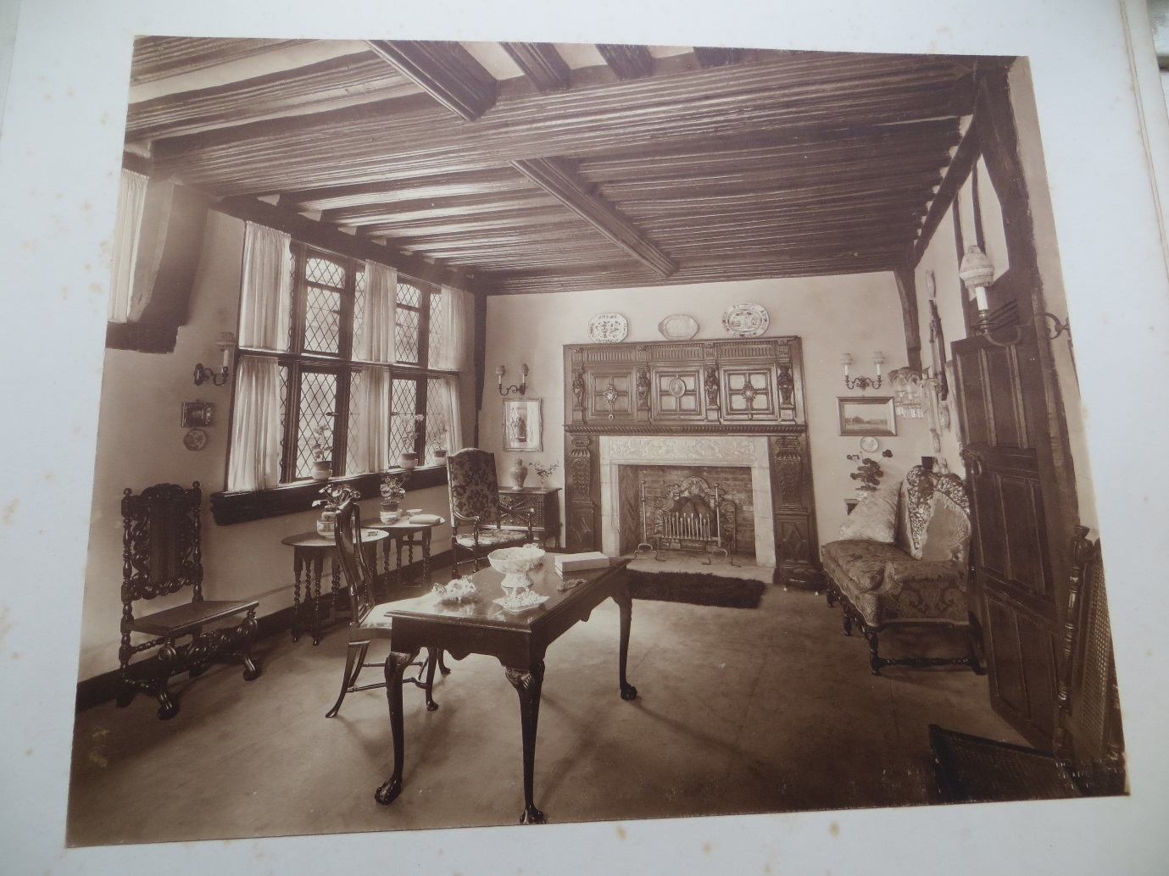
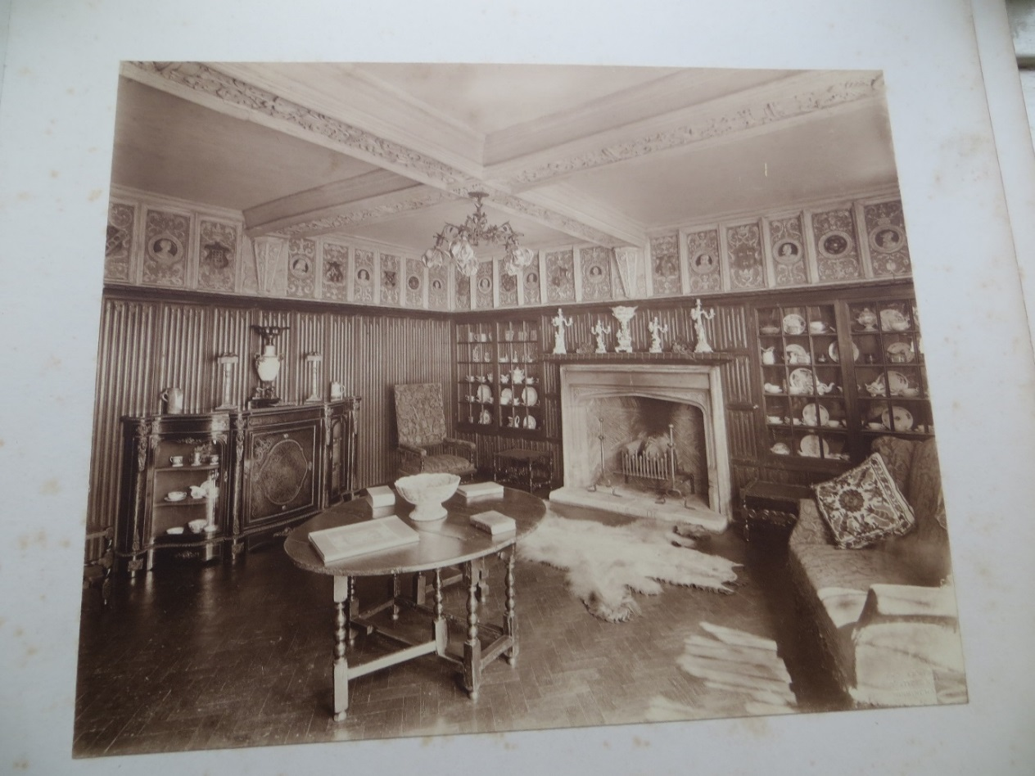

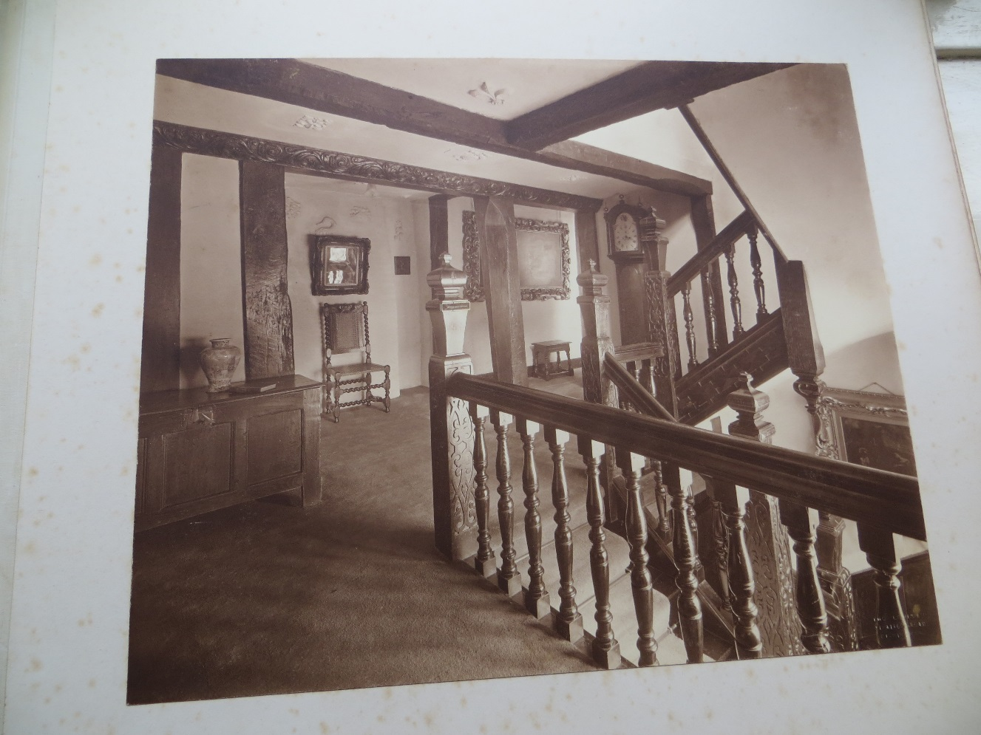
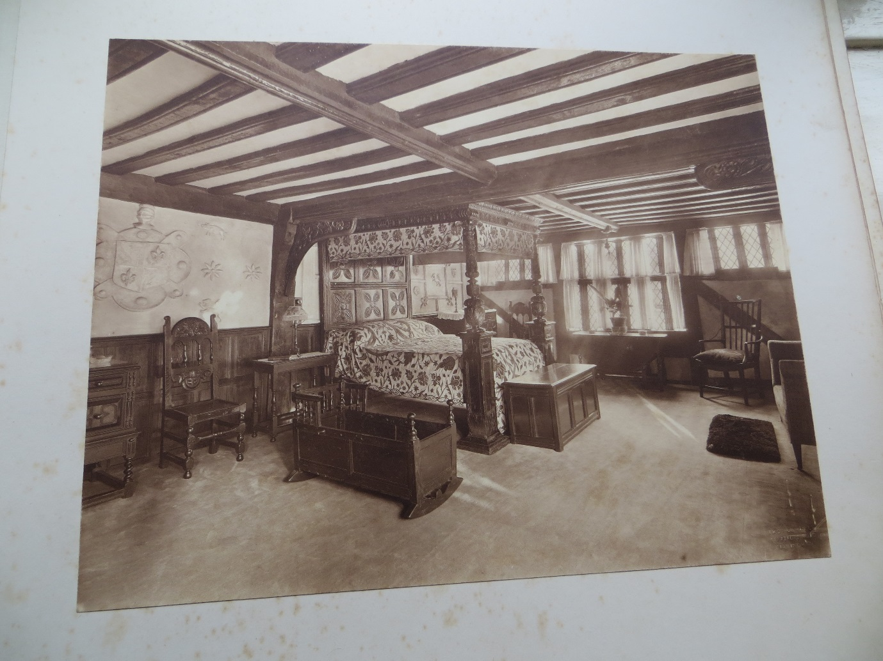
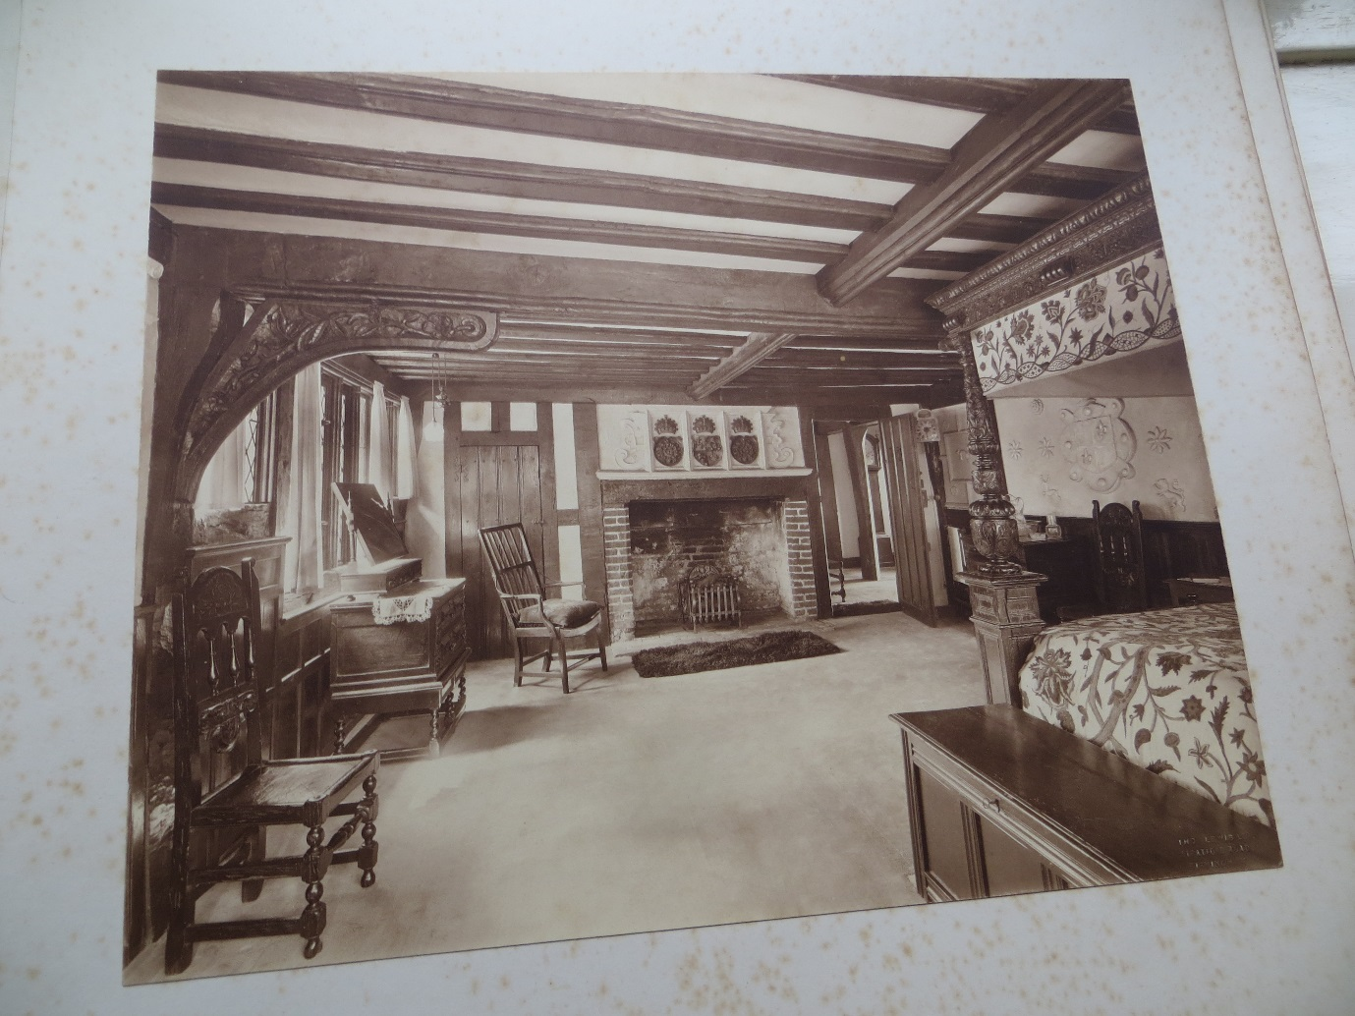
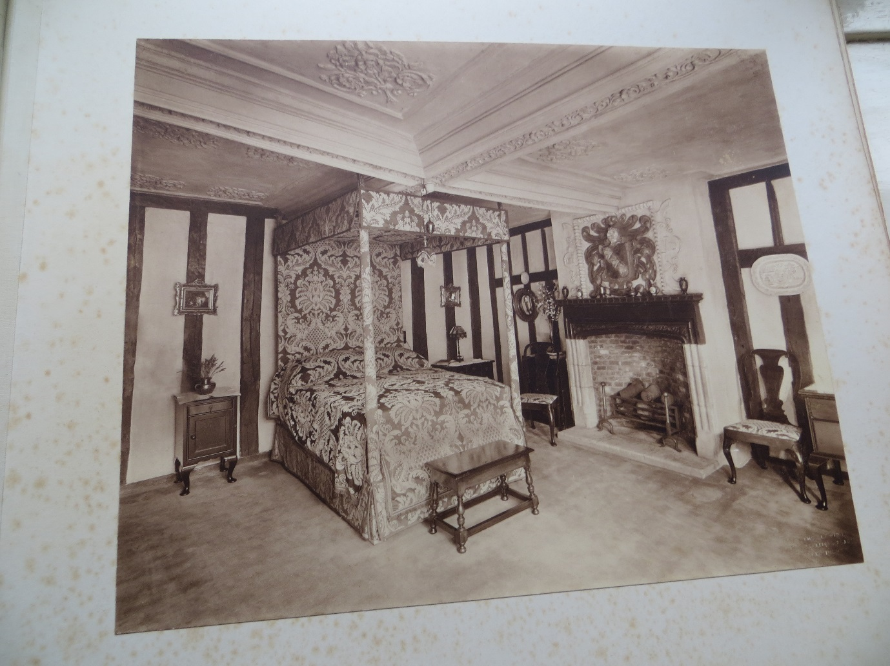
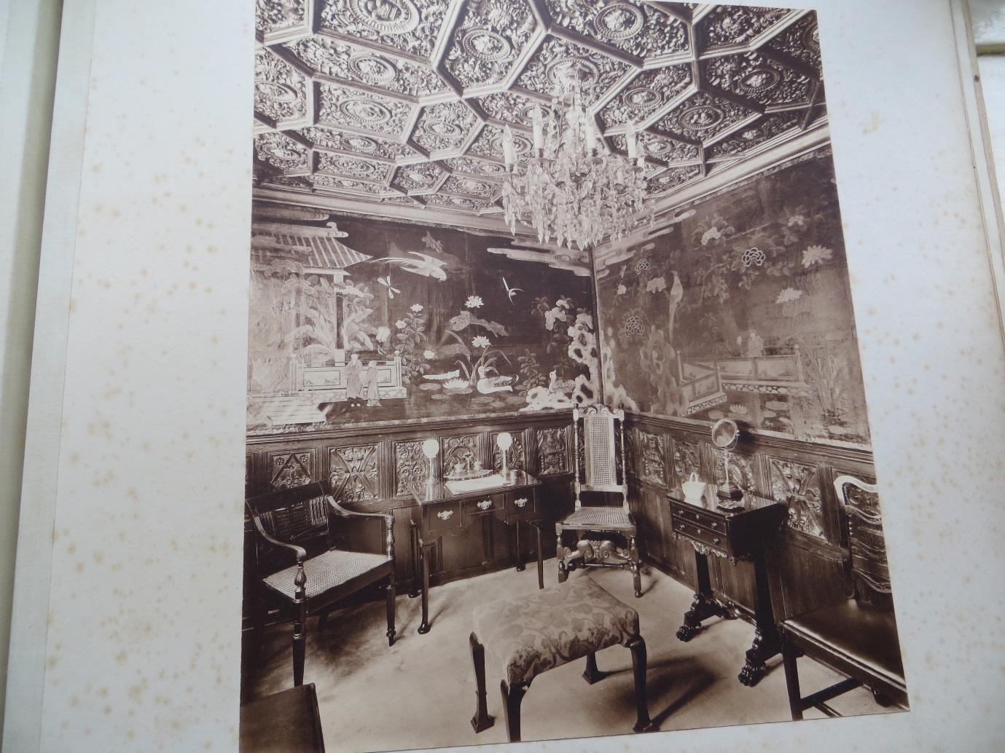
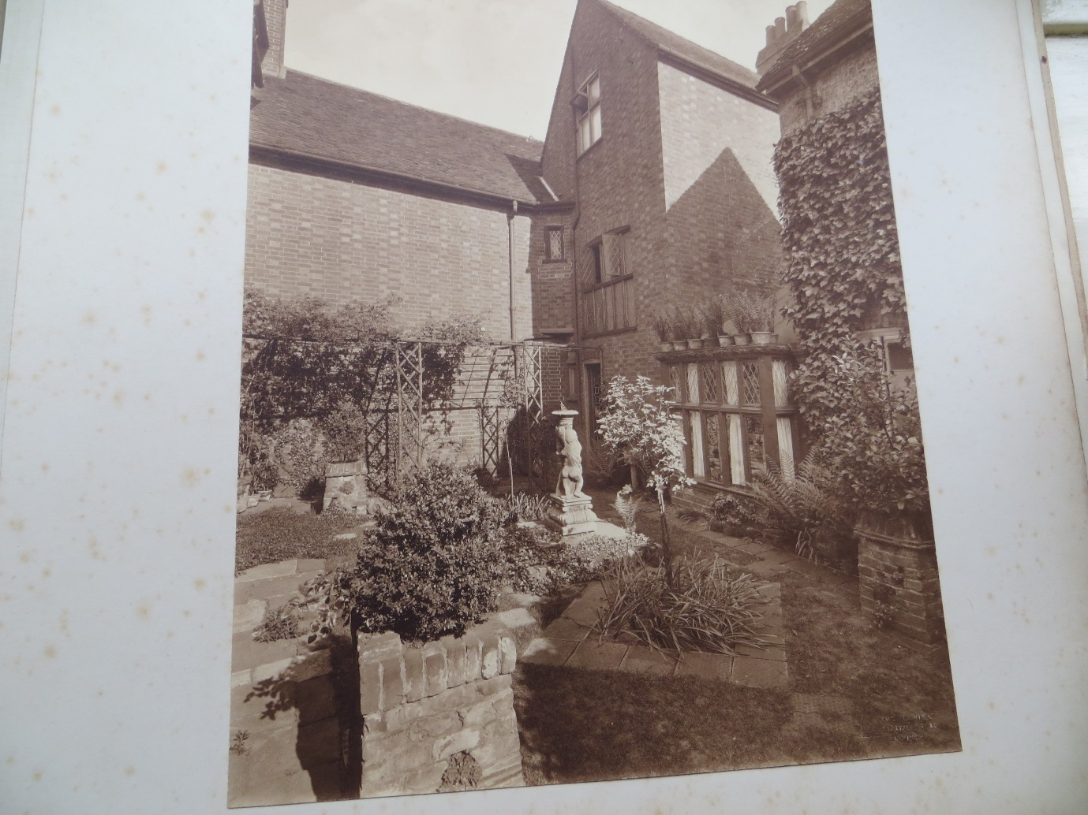

So that was the transformation of the building now known as Pykenham House to greet in the twentieth century. The Cotmans were still in residence as evidenced by the 1901 and 1911 censuses, but as the house size had increased the household members had fallen to just 3 in 1911. They must have been rattling around somewhat.
I have managed to acquire a postcard on Ebay which I think validates my theory as to when the building transformation was complete:
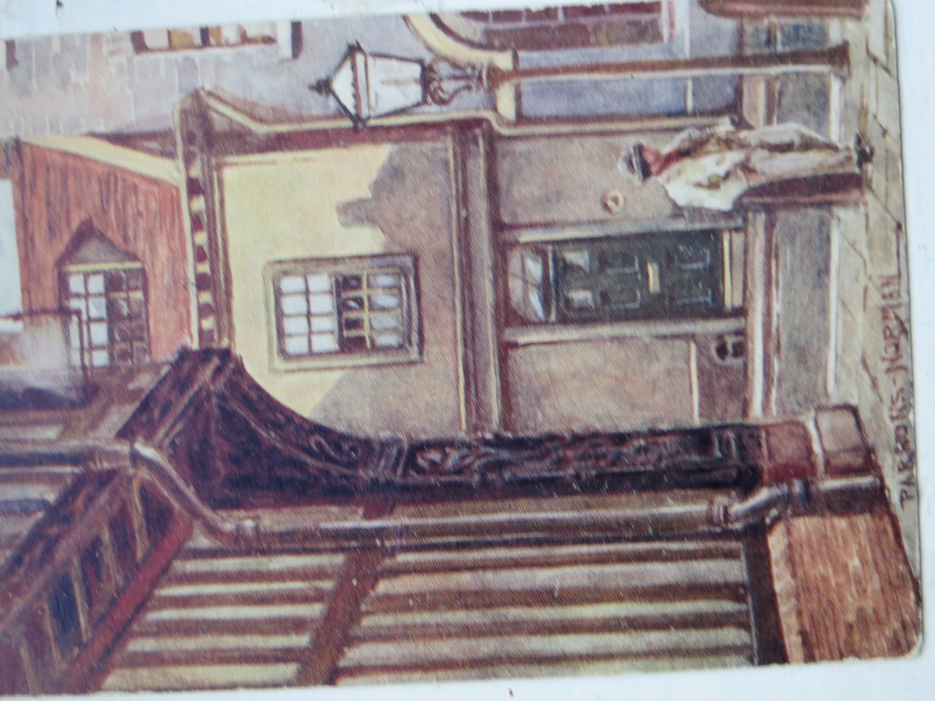

A Parsons Norman painting, in my opinion clearly showing the new building features, and preserved corner post (though the character looks suspiciously like the one outside the Inn in the 1830 print who has got up from his seated posture to now lean against the bollard!).

And here is the reverse of the card showing it was posted to Miss C. Dallaston of 4 Richmond Road Ipswich, from LGD with love in February 1905:

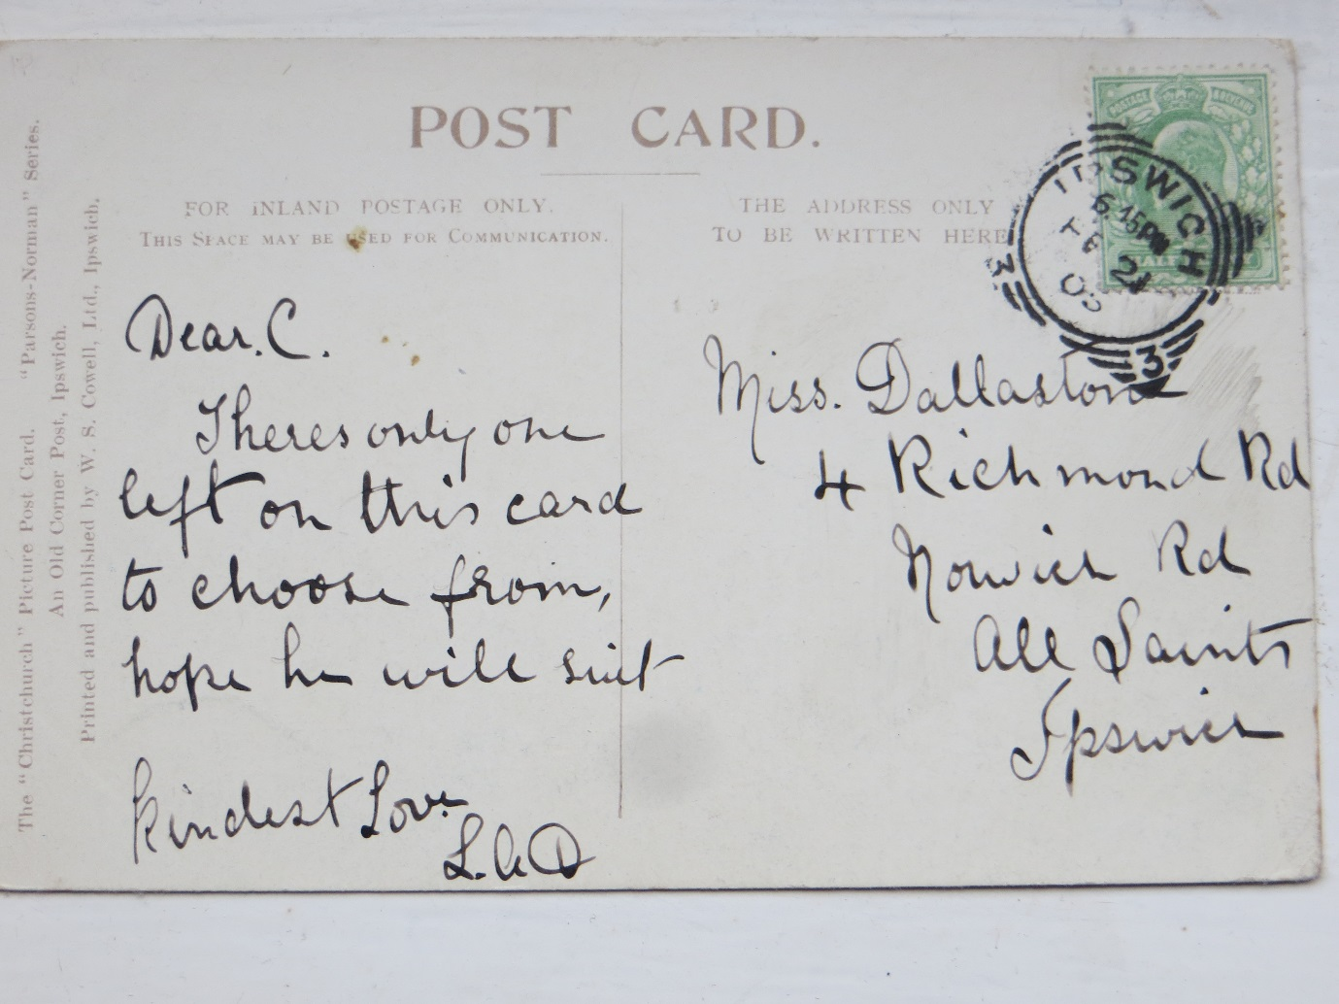

Jackamans
After the death of Thomas Parkington in June 1942, his wife Florence continued to live at Pykenham House until her death on 4th January 1958.
Jackamans as a firm has existed since 1799, nearly 220 years. The first was Simon Jackaman who went on to be Town Clerk, Treasurer to the Association for the Prosecution of Felons and Clerk to the Port Commissioners. His son Simon Batley Jackaman followed a legal career as well as attorney at law and Coroner for Ipswich. In about 1836 Simon Batley Jackaman moved the practice to offices in 37 Silent Street, Ipswich.
There is a rather tragic, and strangely coincidental, newspaper story to recount here from the Ipswich Journal 7th October 1854. It reports on the inquest into the death of Robert Boby, carter age 23, conducted by S. B. Jackman Esq, Coroner. Robert was in fact the son of Robert Boby senior who was at that time publican of the Royal Oak Inn. On a very foggy Saturday night the deceased had been seen at the Railway crossing at Stoke Bridge and had said to a cab driver friend that he would go along the quays to Lower Orwell Street, and that he would be home in a quarter of an hour. He asked his friend to take his wife home by horse cab. He never made it and his body was discovered the following day close to the north pier of the lock gates. The cause of death was stated as drowning by Surgeon Peacock, and the jury returned a verdict of “Found drowned”.
S. B. Jackaman retired in 1873. His two sons Henry Mason Jackaman and William Batley Jackaman had entered the business with their father as attorneys at law when it was known as Jackaman and Sons. H.M. Jackaman then ran the business in his sole name for a while till he joined partnership with Henry William Miller in about 1895, when the firm was known as Jackaman, Sons and Miller. After H. W. Miller’s death in 1916 it reverted to Jackaman and Sons and H. M. Jackaman took his son Henry Simon Batley Jackaman into the partnership till he retired in 1925. H.S.B Jackaman died in 1932 and the practice was taken over by Neville Haywood Smith (formerly of Gudgeons Prentice, Stowmarket) who continued as sole practitioner, and in 1938 he changed the name to Jackaman, Sons and Smith. The firm subsequently became Jackaman, Smith and Mulley in 1947 when Walter Horace Mulley, who had been articled to H. S. B. Jackaman and had worked in London since qualifying as a solicitor in 1932, returned to Ipswich to join the partnership with N. Haywood Smith. The firm changed its name to Jackamans in 2011. By coincidence H. S. B. Jackaman obtained Probate for the estate of Thomas William Cotman in 1925. Jackamans head office is in Ipswich, but it has branches in Felixstowe, Diss and Harleston.
After the Second World war ended many important legislative changes were brought in to give effect to promises made to a war weary Britain for a better future for all. One important area was the listing and thus protection of buildings and structures of special historical, architectural, or cultural importance in the Town and Country Planning Act 1947. Pykenham House had been assessed by the Planners as being of sufficient importance to protect by listing, and this took effect in December 1951:

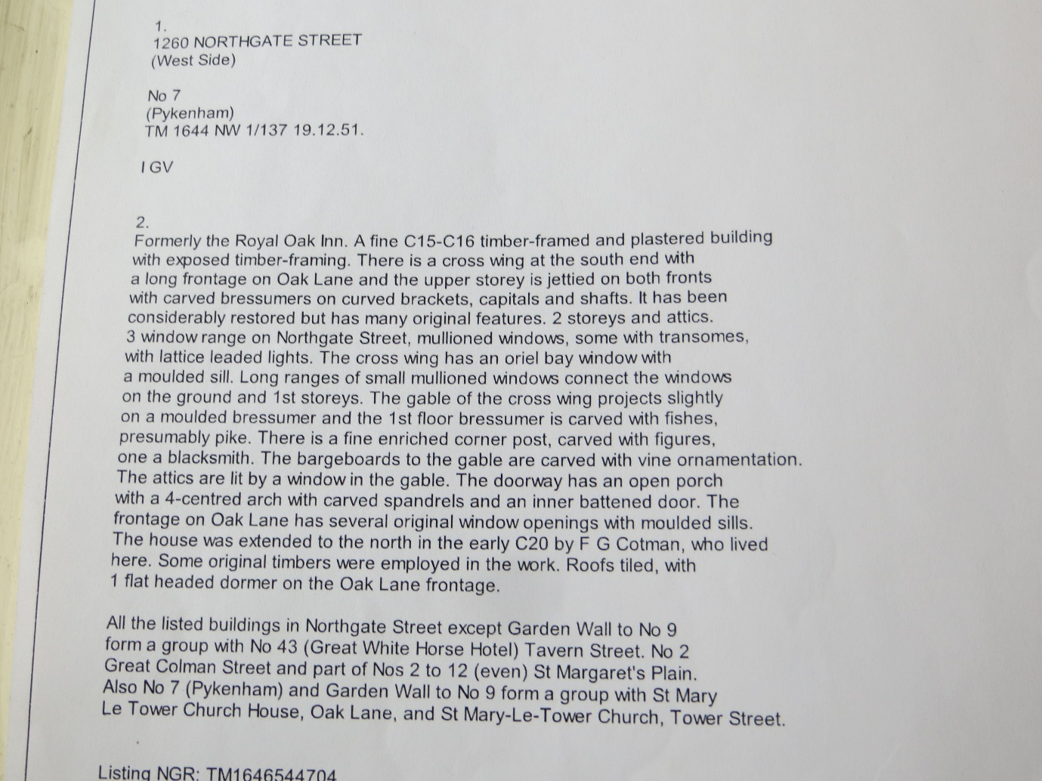
There is a slight error in the listing as it refers to F. G. Cotman as having carried out the extension when it should of course have referred to T. W. Cotman. The Grade One listing appears to have taken place in 1972.
In 1958 W. H. Mulley, known as”Mike”, purchased the freehold of 7 Northgate Street, it is presumed from the executors of the estate of Florence Parkington. By then the building seems to have been called Oak House. The firm Jackaman Smith and Mulley moved into Oak House that same year as its head office, vacating its offices in Silent Street, and has been in occupation ever since covering 60 years of legal business in Northgate Street. Mike died in 2008 and the building belongs to a new owner now.

Afterword
Well, my short history of Oak House is at an end and thank you for taking the time to read it. There are as I have referred to, many missing pieces of the jigsaw yet to be inserted which hopefully will be done by subsequent editions as need be. She is a truly wonderful old building and I will miss her when I retire in just two weeks’ time. When the stressful nature of legal work, with deadlines and knotty abstract problems get too much, just being in a beautiful building which seems to have its own soul, is a calming and beneficial experience.
But I know I am in good company as a member of her appreciation society. She must be one of the most photographed of buildings in Ipswich and countless postcards have featured her image from a range of different angles, and even when the photographer does not know what her official name might be, she is referred to simply as “The Old House“!

